

Nationality :
Preferred Name on Tag:
Name (as per passport , underline family name) :
Passport No :
Dr.
Ms
Mrs
Mr
PARTNER DETAILS
Telephone:
Preferred Name on Tag:
Postcode:
State : Country:
Name (as per passport, underline family name) : Passport No : Passport Expiry Date : Date of Birth: Nationality : Email :
Address:
Dr.
Ms
Mrs
Mr
DELEGATE DETAILS

CONFERENCE, THAILAND July 19-23, 2027

Conference includes:
3 Half-Days of presentations
Nong Nooch Garden tour and lunch
Transfer to and from Bangkok
4 nights at Nong Nooch Resort
Conference breakfast, snacks,
lunch and coffee breaks
Gala dinner

CONFERENCE REGISTRATION FORM
Heliconia Society International XXIII International Conference 2027
19-23 July 2027
Nong Nooch Tropical Botanical Garden
www.heliconia.org

All rates are in US Dollars

Early Bird Conference
(by March 1st, 2027)
Booking
July 19-23, 2027
Single Rate | Double Rate
1,545 | 1,339
Booking (after March 1st, 2027)
July 19-23, 2027
Single Rate | Double Rate
1,854 | 1,607

* Conference has limited to attendees.
* Double rate- Double occupancy in a hotel room, limited two-bed options available.

  - Prices subject to change without prior notice.
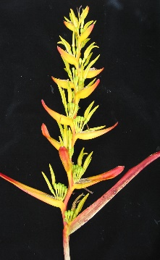
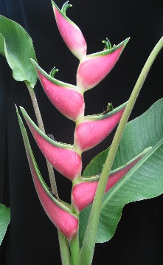
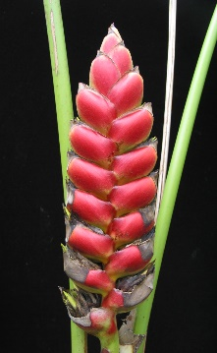
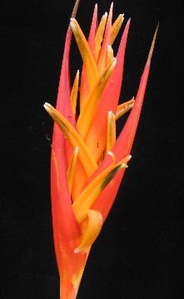
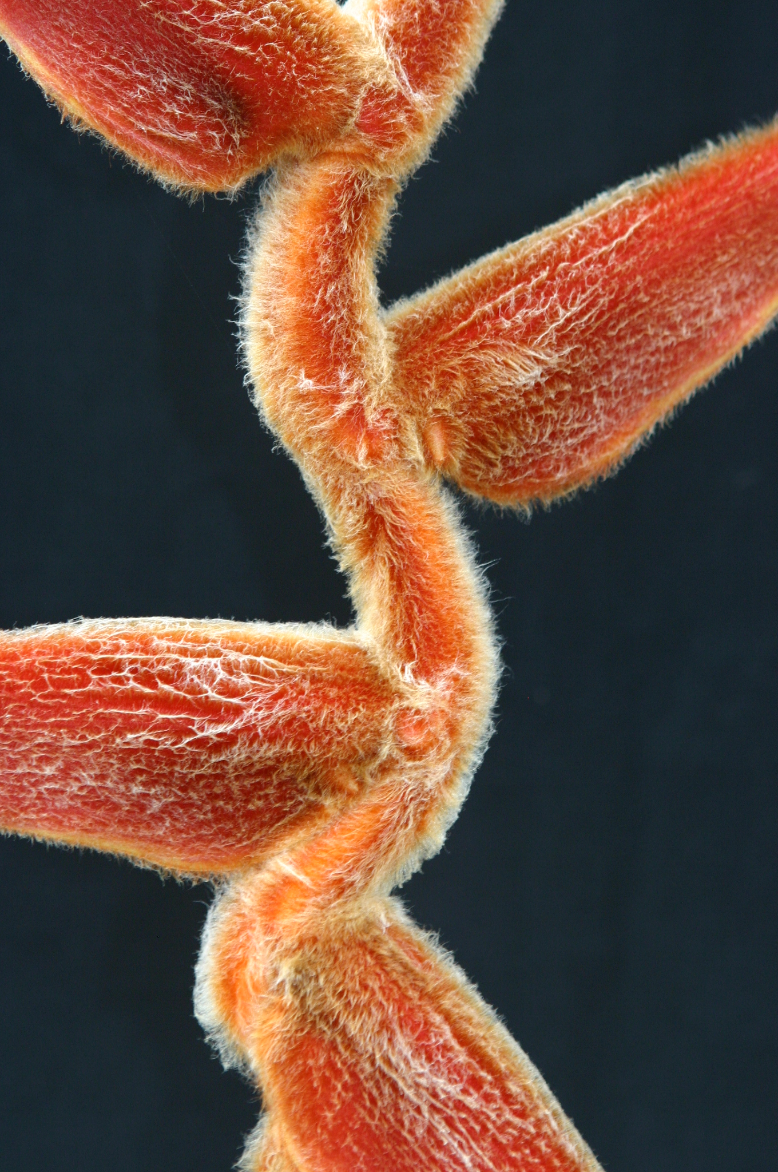
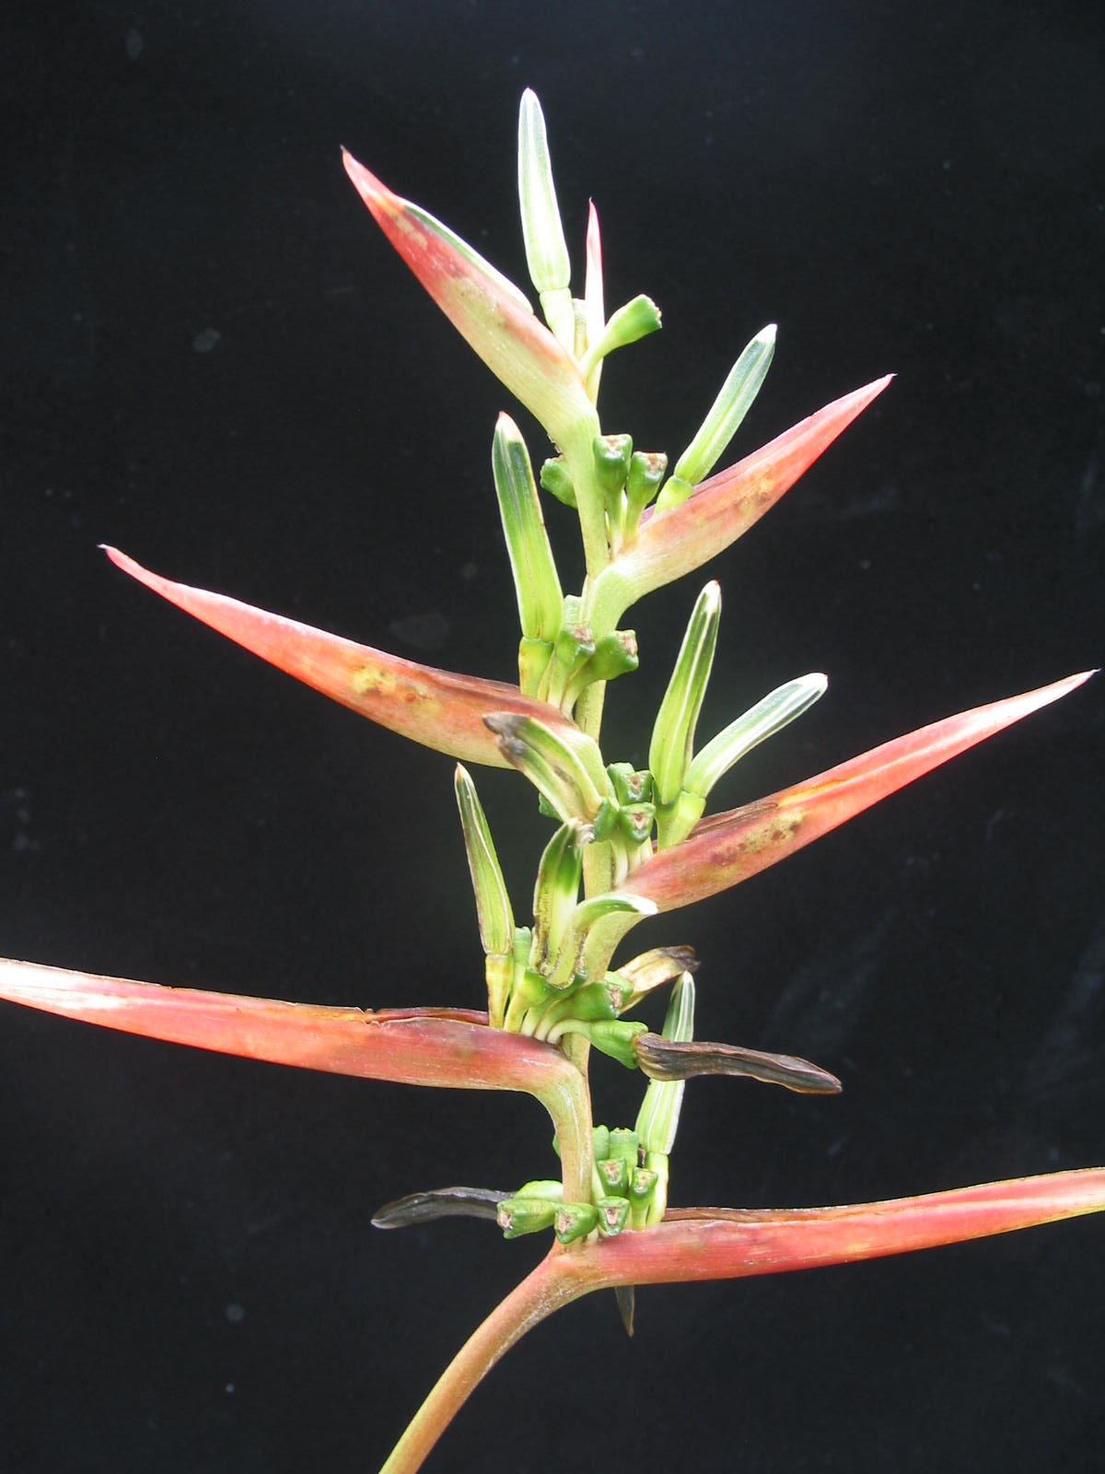
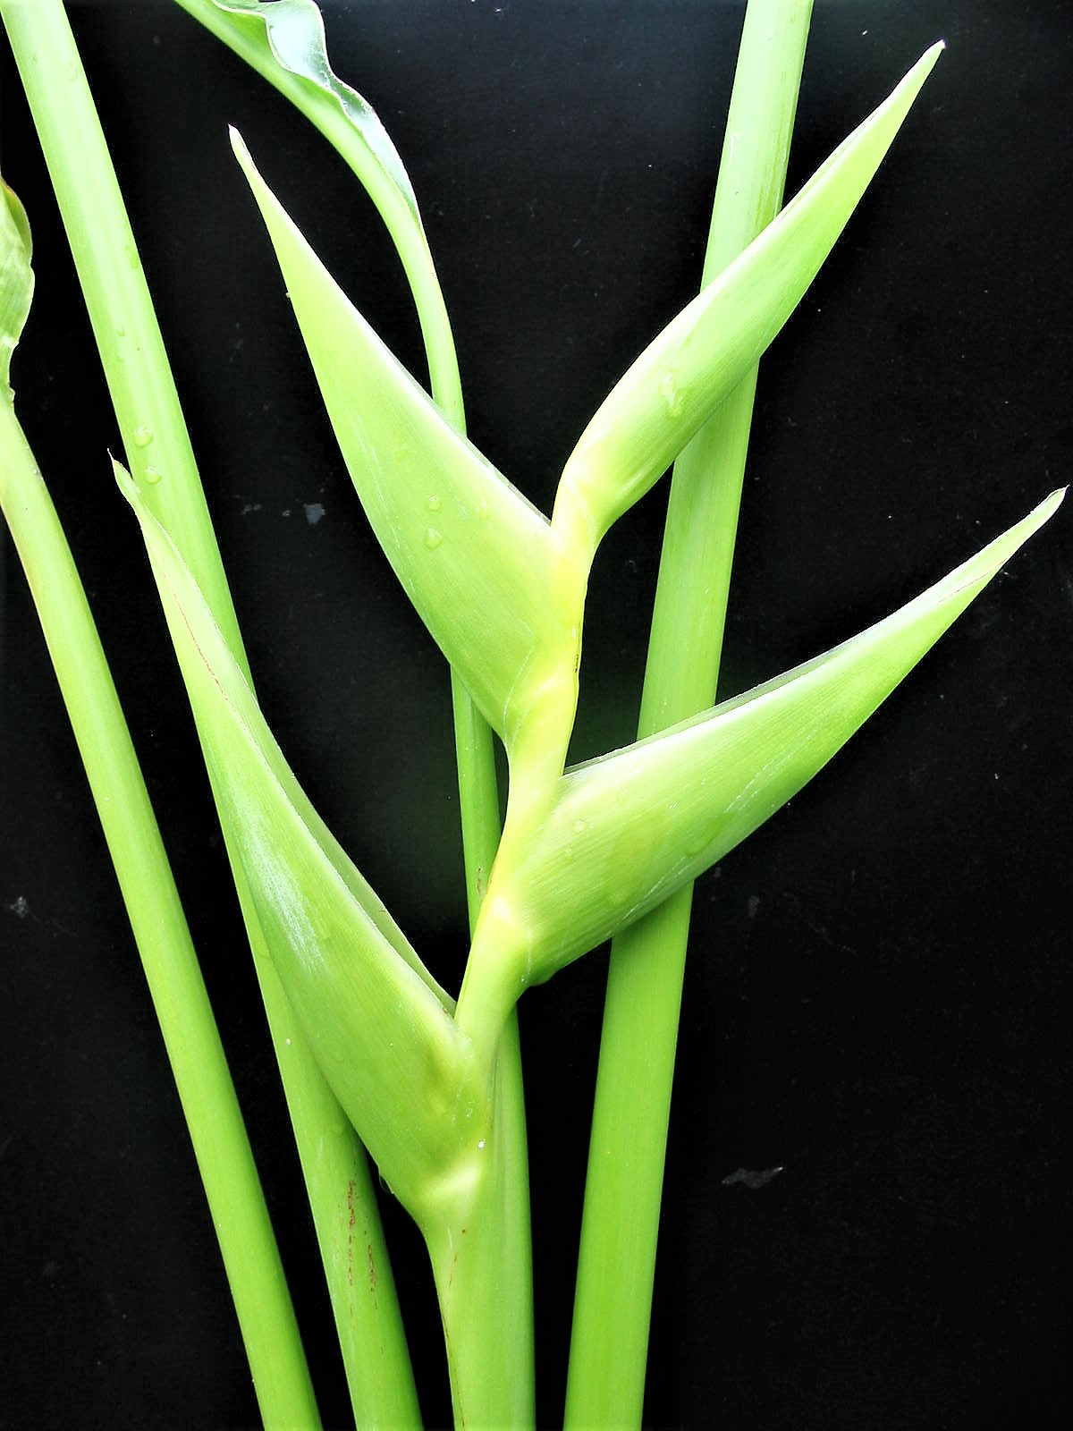
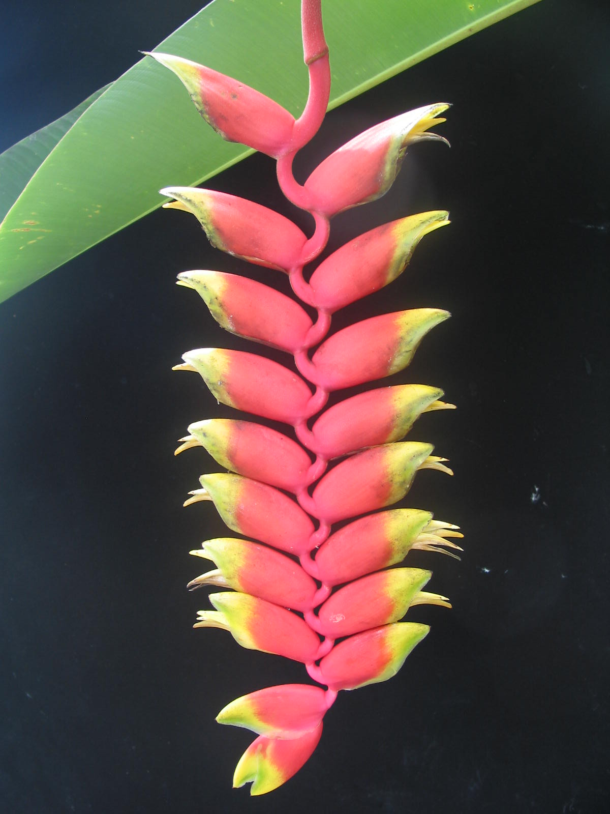
  - Prices are based on a minimum group size of 35 persons

CONFERENCE REGISTRATION FORM
Heliconia Society International
XXIII International Conference 2027
19-23 July 2027
Nong Nooch Tropical Botanical Garden
www.heliconia.org

Chiang Mai POST TOUR July 23-26, 2027

4 days 3 nights
Post tour
Early-Bird Booking
(by March 1st, 2027)
Single Rate | Double Rate
886 | 703
Booking (after March 1st, 2027)
July 23-26, 2027
Single Rate | Double Rate
1,063 | 844
      - 3 nights at Movenpick Suriwongse Hotel, Chiang Mai
      - Transportation to tour destinations and airport shuttle
      - Tours of local Ginger Nurseries, Majo University, Queen Sirikit Botanical Garden. Snacks, beverages
      - One way flight Bangkok to Chiang Mai
      - Start; Nong Nooch, Pattaya End: Chiang Mai

* Tour limited has limited space
* Double rate- Double occupancy in hotel room, limited two-bed options available.

.

*DIETARY INFORMATION- Please choose a dietary choice for planned meals : ……………………………………………

*If you have special dietary information, please inform us.

- Prices subject to change without prior notice.
- Prices are based on minimum group size of 30 persons

CONFERENCE REGISTRATION FORM
Nationality :
Preferred Name on Tag:
Name (as per passport, underline family name) :
Passport No :
Dr.
Ms
Mrs
Mr
PARTNER DETAILS
Telephone:
Preferred Name on Tag:
Postcode:
State : Country:
Name (as per passport, underline family name) : Passport No : Passport Expiry Date : Date of Birth: Nationality : Email :
Address:
Dr.
Ms
Mrs
Mr
DELEGATE DETAILS
Heliconia Society International
XXIII International Conference 2027
19-23 July 2027
Nong Nooch Tropical Botanical Garden
www.heliconia.org

Payment Calculation
Membership in HSI* X =

Conference X =
Chiang Mai post Tour X =
Other Service X =

Total

- Participants must be member of HSI
Membership Rates
Student - $10.50
PDF - $26.25
Individual - $52.50
Library - $36.75
Corporate - $105
Sustaining - $525
Lifetime - $1,050
If you are not yet a member, please choose one of the
categories, renewals welcome.

*Membership rates include
5% payment processing fee

Payment is only available through PayPal invoice.
Send your completed form by email to confirm registration
HSI2027conference@gmail.com
Feel free to contact either Carla Black or Anders Lindstrom with any questions.

Participants must be members of HSI.
If you are not yet a member, please visit heliconia.org/joinhsi to join us

HSI Coordinator Carla Black
+507 6747-3039
HSI2027conference@gmail.com

Official Conference Organizer
Anders Lindstrom
+66 819076905
HSI2027conference@gmail.com

All changes and cancellations must be made in writing. Cancellation penalty prior to departure date (per person): 60 days or more USD 300.-
59 or fewer 100% of total fare

